De Profundis

Psalm 130 (129)

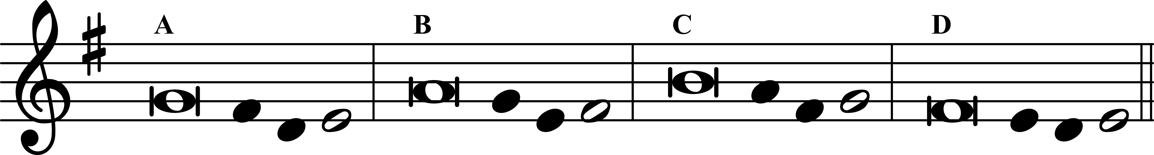
1 Out of the depths I cry to you, O Lord;
2 Lord, hear my voice!
O let your ears be attentive
to the sound of my pleadings.
3 If you, O Lord, should mark iniquities,
Lord, who could stand?
4 But with you is found forgiveness,
that you may be revered.
5 I long for you, O Lord,
my soul longs for his word.
6 My soul a‧waits the Lord
more than watch‧men for daybreak.
More than watch‧men for daybreak,
7 let Israel hope for the Lord.
For with the Lord there is mercy,
in him is plenti‧ful redemption. ——
8 It is he who will re‧deem Israel
from all its iniquities.

V. Eternal rest grant unto them, O Lord.
R. And let perpetural light shine upon them.

O Sacrum Convivium

O Sacred Banquet
in which Christ becomes our food,
the memory of His passion is celebrated,
the soul is filled with grace,
and a pledge of future glory is given to us.

V. You gave them bread from heaven. (E.T. Alleluia.)
R. Containing every blessing. (E.T. Alleluia.)
Let us pray.
O God, who in this wonderful Sacrament
have left us a memorial of your Passion,
grant us, we pray,
so to revere the sacred mysteries of your Body and Blood
that we may always experience in ourselves
the fruits of your redemption.
Who live and reign with God the Father,
in the unity of the Holy Spirit,
one God, for ever and ever.

Dominican Vocation Prayer

Blessed Father Dominic, preacher of God’s grace,
you promised to assist us, even after your death.
Intercede for us before God
to help us encourage more men and women
to follow our way of life, the way of a preacher.
Bless us in our common life, study, prayer and ministry,
that our lives together may be a joyful witness,
creating a desire in others to join the Sacred Preaching.
Amen.

